**Assignment 4**

**Due, Sunday, June 25, 2017 for maximum 100**

**Monday, June 26, 2017 for maximum 90**

**Tuesday, June 27, 2017 for maximum 80**

**Wednesday, June 28, 2017 for maximum 70**

**Assignment Scope**

1. Adding member variables or instance variables to a class
2. Using Java API classes from javax.swing.* package
3. Developing a User Interface

**Deliverables**

To complete this assignment you must submit your **compressed Netbeans project** to Webcourses.

**Tasks and Rubric**

|  |  |  |
| --- | --- | --- |
| Activity | | |
| Boggle.java | 1. Add to method **main()**    1. Instantiate an instance of class **BoggleUi**, passing the reference object of class **Board** as an argument |
| userInterface package | 1. Create class **BoggleUi** |
| BoggleUi.java | 1. Add member variables of type    1. JFrame    2. JMenuBar    3. JMenu    4. JMenuItem    5. JMenuItem    6. JPanel    7. JButton[][]    8. JPanel    9. JScrollPane    10. JTextPane    11. JLabel    12. JButton    13. JPanel    14. JLabel    15. JButton    16. JLabel 2. A custom constructor should be defined that receives a parameter of type Board class    1. Set member variable of type class **Board** to the parameter passed in    2. call method **initComponents()** 3. A method **initComponents()** should initialize all the components for the UI and called from the constructor    1. ~~Set the default size of the~~ **~~JFrame~~**    2. ~~Set the default close operation of the~~ **~~JFrame~~**    3. ~~Use default layout manager~~ **~~BorderLayout~~**    4. ~~Set up the~~ **~~JMenuBar~~**       1. **~~JMenu~~** ~~Boggle should be added to the~~ **~~JMenuBar~~**       2. **~~JMenuItems~~** ~~New Game and Exit should be added to the~~ **~~JMenu~~** ~~Boggle~~    5. ~~A~~ **~~JPanel~~** ~~should be created to hold the current word being created by the user~~       1. ~~Recommend using default Layout Manager~~ **~~FlowLayout~~**       2. ~~A~~ **~~JLabel~~** ~~for the current word being created~~       3. ~~A~~ **~~JButton~~** ~~to submit the current word created~~       4. ~~A~~ **~~JLabel~~** ~~for the player’s score~~    6. ~~A~~ **~~JPanel~~** ~~should be created to hold the~~ **~~JButtons~~** ~~of dice~~       1. The **JPanel** for the Boggle board should be a 4 x 4 grid that displays a **JButton** for each die       2. ~~Recommend using Layout Manager~~ **~~GridLayout~~**    7. ~~A~~ **~~JPanel~~** ~~should be created to hold~~        1. ~~Recommend using Layout Manager~~ **~~BoxLayout~~**       2. ~~the~~ **~~JTextArea~~** ~~for the user to enter their words~~       3. ~~the~~ **~~JScrollPane~~** ~~for the~~ **~~JTextArea~~** ~~to scroll as necessary~~       4. ~~the~~ **~~JLabel~~** ~~that displays time left for the current round of play~~       5. ~~the~~ **~~JButton~~** ~~to shake the dice~~    8. **~~JMenuBar~~** ~~should be set on the~~ **~~JFrame~~**    9. Add all the components to the **JFrame**    10. ~~Set the visibility of the~~ **~~JFrame~~** |
| Boggle application |  |
| Test Case 1 | Test Case 1 passes |
| Test Case 2 | Test Case 2 passes |
| Test Case 3 | Test Case 3 passes |
|  | Source compiles with no errors |
|  | Source runs with no errors |
|  | Source includes comments |
| Total |  |

**Perform the following test cases**

|  |  |  |
| --- | --- | --- |
| Test Cases | | |
|  | **Action** | **Expected outcome** |
| Test Case 1 | **User interface displays** | User interface is similar to figure 1 |
| Test Case 2 | **Boggle menu** | Boggle menu looks like figure 2 |
| Test case 3 | **Project view** | Project view matches figure 3 |

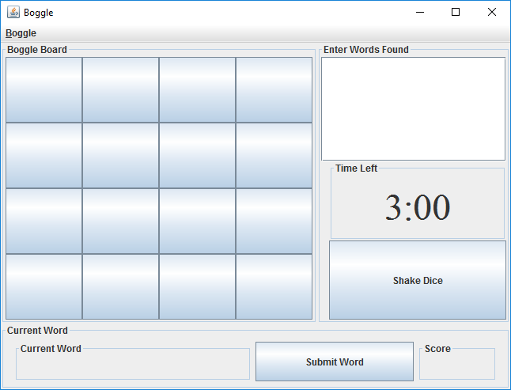

Figure 1 Test Case 1

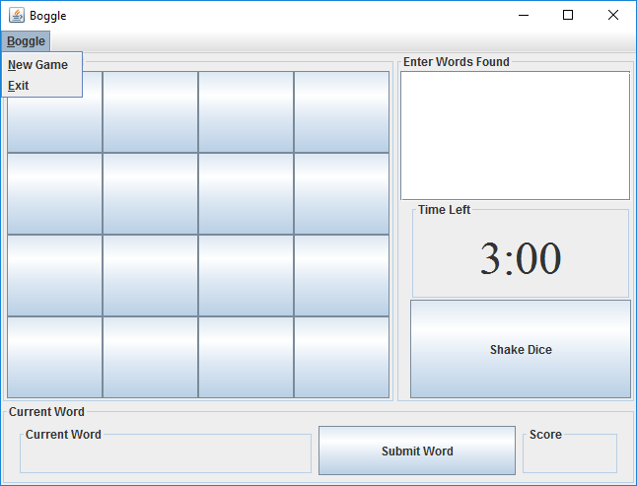

Figure 2 Menu Boggle

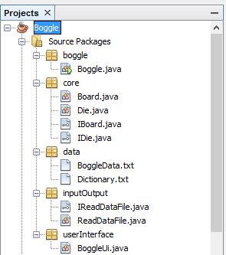

Figure 3 Project View